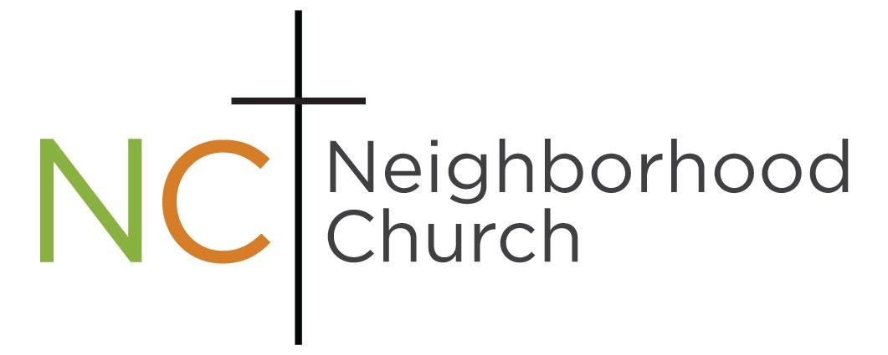

2021 Annual Church Report

Bringing the Love of Jesus into our Community

Board Members & Staff of 2021

Board Members
- Fred Fay President
- Tom Zumek Vice President
- Ken Schmidtke Officer
- Mark Haskins Secretary
- Jessica Morse Treasurer

Staff Members
- Fred Fay – Lead Pastor & Board President
- Pam Fay – Pastor, Women’s Ministries & Bookkeeper
- Kevin & Martie Schultz – Worship Team
- Kevin Schultz -Discipleship
- Ralph King –Prayer ministry, Men’s Ministry & Building oversight
- Chris Anderson- Worship, Media and Youth.

Membership Roster

- Vera Bussell
- Brian Chapman
- Virginia Chapman
- Lyn Carone
- Mike Davis
- Corina Farmer
- Michael Farmer
- Becca Fay
- Fred Fay
- Jessica Fay
- Pam Fay
- Cynthia Fahlgren
- Graham Fenton
- Javier Figueroa
- MaryKay Figueroa
- Bill Hannon
- Pam Hannon
- Kristin Haskins
- Mark Haskins
- Lavone Marie Holzborn
- Penny King
- Ralph King
- Harvey Kuartel
- Cindy Luke
- Greg Luke
- Madelyn Luke
- Randy Luke
- Sandi Luke
- Thomas Luke
- Margaret Lundberg
- Ralph Lundberg
- Cindy Manson
- Don Manson
- Tori McGill
- Kevin McKay
- Wilka Michaelson
- Leslie Montgomery
- Naomi Montgomery
- Ingrid Mortensen
- Pat Olson
- Judy Schmidtke
- Ken Schmidtke
- Kevin Schultz
- Martie Schultz
- Jodi Thomason
- Lance Thomason
- Josh Wright
- Kristina Wright
- Angie Zumek
- Tom Zumek

2021 Church Average Attendance: 91

On location: 43
Online: 48

2021 Giving

Compassion Ministries:
- Graham Women (Addition recovery) $1550
- Convoy of Hope (Relief efforts) $2100
- Olive Crest (Adoption Service) $600
- Families Unlimited Network (Food Bank & family services) $1100
- Community Dinners $6644
- The Table church plant $500
- Prison outreach $1500
- Christmas Family $850
- Apartment Christmas gifts $200

US Missions:
1. Dave and Sue Hartmann- Refugees $1200
2. Denise Geesey- Build A Hand. Families and Children $300
3. Les Welk- MRI, Ministry Resources International $600
4. Youth for Christ $600

World Missions:
- Doug and Tasha Myers- Ethiopia $600
- Brad and Roberta Shimomura- Japan $4710
- Alvin and Lace Leota- Middle East $1200
- Steve and Seely- China $600
- Jeff and Pam Gregory- Europe $600
- Alex and Amy Krutov -Russia “The Harbor”. $700
- Paul and Stephanie Wendler- Asia $1700
- Alex Opoku-Mensah- Ghana $125
- Wes and Alison Stover -Mozambique $1200
- Chris and April Hinkle- Middle East $300

Profit & Loss
January through December 2021

Ordinary Income/Expense
Income
4000- Offerings 193,712
4010- Foreign Missions 13,810
4012- Compassion Ministry 22,235
4015- Home Missions 500
4020- Benevolence 00
4025- Building Fund 2385
4027- Youth 7542
4010- Rent 75,287

Total Income $315,501

Gross Profit $315,501

Expenses
6000- Payroll 161,863
7000- Operating Expenses 38,350
7120- Utilities 18,018
7200- Foreign Missions 8843
7205- Home Missions 3950
7207- Compassion 15,154
7209- Building 25,249
7030- Youth/Children 4800

Total Expense $276,227

Net Income 39,273

Ministry Report
Community Dinners
Our community dinners were hit hard with Covid restrictions. We did open to in person service in October. We averaged 30 people every week in person and 12 in door-to-door distribution. Recently, we have seen the numbers start to climb again. We serve a wonderful dinner, present a short gospel message, and offer prayer. So many of our guests want prayer every week. Most importantly, people are in a community in sharing their lives together. This IS church for many of them.
Our director, Beckie Daughtry did a great job. When she moved to Alaska people stepped up to keep the ministry going. A big thank you goes to Lyn Carone, Laurie Patko, Maddy Luke, Kristin Haskins, Randy and Sandi Luke, Syl Fields and Wilka Michaelson.
Youth Ministry
Despite its challenges, it has been a great year for NC youth. Youth Retreat was a highlight this year. There was a move of the Lord as many young people responded to a move of the Lord. One of the highlights was that we had 4 people baptized.
We have had youth join our leadership teams on Sunday morning. A big thank you for all those who are volunteer with our youth; Brian Chapman, Maddy Luke, Randy and Sandy Luke and Alison Woods.
Online service
We have been broadcasting our service on Facebook Live since March. We average 20-25 people online in real time and many hits (150 or so) during the week. We’ve added two cameras and other equipment.

Worship Nights
Our monthly worship nights have been an encouragement to many people, both of our church and others who joined us. We had 8 representatives from other churches.
Discipleship
We’ve began a process of developing discipleship avenue for the church. In the Fall connect groups began with 43 people attending. We have hired a consultant helping us develop this process. Thank you to Keyin Schultz for taking the lead in this.
Staff
It is so good to be a part of a team that work together. We are all doing our best to follow Jesus. Thanks to Ralph King, Kevin and Martie Schultz and Chris Anderson. It is a privilege to serve with a very supportive and creative Church Board. Thank You Tom Zumek, Jessica Fay, Ken Schmidtke and Mark Haskins. Also, a big thank you to Angie Zumek for coordinating the First Impression team. Most of all I thank, Pam, my amazing wife who continually cheer me on.
Respectfully submitted,
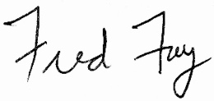
Fred Fay

